EXPERIMENT 3
STATISTICAL DESCRIPTION
Name: RONAL SHOEY GEORGE
Date: 01-01-2025
Class: S6DS
Roll No.: 51

PROGRAM
a<-c(10,15,20,25,30,35,40,45,50)
b<-c(5,10,15,20,25,30,35,40,45)
cat('Data A : ',a)
cat('Mean : ',mean(a))
cat('Median : ',median(a))
cat('Summary : ',summary(a))
s1<-'con'
s2<-'cat'
cat('Min : ',min(a))
cat('Max : ',max(a))
cat('1st Qaurtile : ',quantile(a,0.25))
cat('3st Qaurtile : ',quantile(a,0.75))
cat('Summary : ',summary(a))

cat('Variance : ',var(a))
boxplot(a,main='Boxplot of A',col='cyan')

cat('Data B : ',b)
cat('Covariance of A and B : ',cov(a,b))
cat('Correlation of A and B : ',cor(a,b))

OUTPUT

Data A : 10 15 20 25 30 35 40 45 50
Mean : 30
Median : 30
Summary : 10 20 30 30 40 50
Min : 10
Max : 50
1st Qaurtile : 20
3st Qaurtile : 40
Summary : 10 20 30 30 40 50
Variance : 187.5
Data B : 5 10 15 20 25 30 35 40 45
Covariance of A and B : 187.5
Correlation of A and B : 1

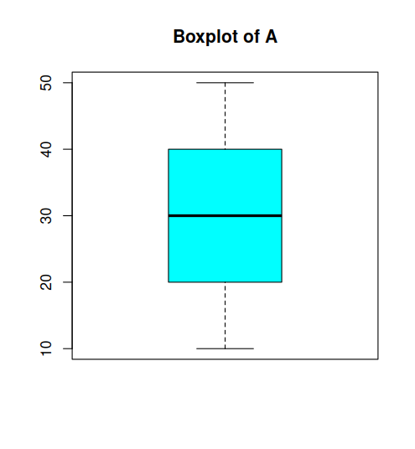
EXPERIMENT 4
VARIANCE, COVARIANCE, CORRELATION
Name: RONAL SHOEY GEORGE
Date: 08-01-2025
Class: S6DS
Roll No.: 51

PROGRAM
data <- read.csv("/home/ds-da-14/Ronal/R-Lab-S6/data2.csv", row.names = 1)

variance_yes <- var(data$yes)
variance_no <- var(data$no)

covariance <- cov(data$yes, data$no)

coefficients <- cor(data$yes, data$no)

chi_square_test <- chisq.test(data)

print(paste("\nVariance (yes):", variance_yes))
print(paste("\nVariance (no):", variance_no))
print(paste("\nCovariance:", covariance))
print(paste("\nCoefficients (correlation):", coefficients))
print(chi_square_test)

chi_square_values <- as.vector(chi_square_test$observed - chi_square_test$expected)
chi_square_sum <- sum(chi_square_values^2 / chi_square_test$expected)

plot_data <- data.frame(
Category = rownames(data),
ChiSquareValues = chi_square_values
)

plot(data,chi_square_values)

boxplot(data$yes,data$no,names=c("Yes","No"),main="Boxplot of Yes and No",na.rm=TRUE)
OUTPUT

[1] "Variance (yes): 148"
[1] "Variance (no): 81.3333333333333"
[1] "Covariance: 102"
[1] "Coefficients (correlation): 0.929683296797258"

Pearson's Chi-squared test

data: data
X-squared = 1.5725, df = 2, p-value = 0.4556

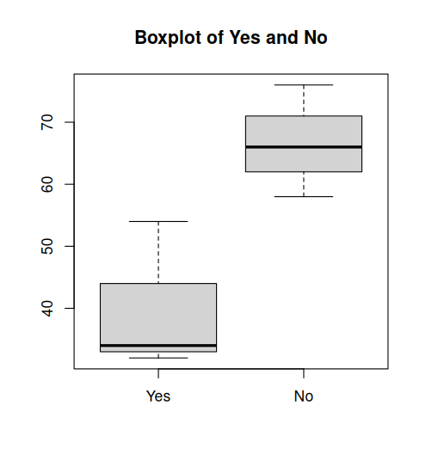
EXPERIMENT 5
MENU DRIVEN
Name: RONAL SHOEY GEORGE
Date: 08-01-2025
Class: S6DS
Roll No.: 51

PROGRAM
combine_datasets<-function(df1,df2,method='rbind'){
if (method=='rbind'){
return (rbind(df1,df2))
}
}
is_palindrome<-function(df){
print(df)
mat<-as.matrix(df)
rownames(mat) <- NULL
colnames(mat) <- NULL
return (identical(mat,t(mat)))
}
find_min_max<-function(df){
max_row<-apply(df,1,max)
min_row<-apply(df,1,min)
max_col<-apply(df,2,max)
min_col<-apply(df,2,min)
return(list(max_row = max_row, min_row = min_row, max_col = max_col, min_col = min_col))
}
fibonacci<-function(n){
fibs<-numeric(n)
fibs[1]<-1
if (n>1) fibs[2]<-1
for (i in 3:n){
fibs[i]<-fibs[i-1]+fibs[i-2]
}
return (fibs)
}
factorial_of_fibonacci<-function(n){
fibs<-fibonacci(n)
print(sapply(fibs,factorial))
}
check_fibonacci_in_dataframe<-function(df){
fibs <- fibonacci(max(df))
fin <- c()
for (i in df) {
for (j in i) {
if (j %in% fibs) {
fin <- c(fin, j)
cat("Fibonacci number ", j, " found in dataframe.\n")
cat("Factorial of ", j, " is ", factorial(j), "\n")
}
}
}
fin
if (length(fin)==0){
cat("No Fibonacci numbers found in dataframe.\n")
}else{
cat("Fibonacci numbers in dataframe :\n")
print(fin)
cat("Factorials of Fibonacci numbers in dataframe:\n")
print(lapply(fin,factorial))
}

}
menu<-function(){
cat("Menu : \n")
print("1. Combine two datasets")
print("2. Check if dataframe is palindrome")
print("3. Find max and min of each row and column of a dataframe")
print("4. Check for Fibonacci numbers in dataframe and display their factorials")
print("5. Exit")
choice<-as.integer(readline(prompt = "Enter your Choice : "))
return (choice)
}
main<-function(){
repeat{
choice<-menu()
if (choice==1){
df1 <- data.frame(a = c(1, 2, 3), b = c(4, 5, 6))
df2 <- data.frame(a = c(7, 8, 9), b = c(10, 11, 12))
cat("Df1 : \n")
print(df1)
cat("Df2 : \n")
print(df2)
combine_datasets(df1,df2)
}else if (choice ==2){
dfp<-data.frame(a=c(1,2,3),b=c(2,1,2),c=c(3,2,1))
print(is_palindrome(dfp))
}else if(choice ==3){
df <- data.frame(a = c(1, 2, 3), b = c(4, 5, 6), c = c(7, 8, 9))
print(find_min_max(df))
}else if (choice==4){
df <- data.frame(a = c(1, 2, 3), b = c(4, 5, 6), c = c(7, 8, 9))
check_fibonacci_in_dataframe(df)
}else if (choice ==5){
cat("Exiting...\n")
break
}else{
cat("Invalid choice!")
}
}
}

main()

OUTPUT

Menu :
[1] "1. Combine two datasets"
[1] "2. Check if dataframe is palindrome"
[1] "3. Find max and min of each row and column of a dataframe"
[1] "4. Check for Fibonacci numbers in dataframe and display their factorials"
[1] "5. Exit"
Enter your Choice : 1
Df1 :
a b
1 1 4
2 2 5
3 3 6
Df2 :
a b
1 7 10
2 8 11
3 9 12
Menu :
[1] "1. Combine two datasets"
[1] "2. Check if dataframe is palindrome"
[1] "3. Find max and min of each row and column of a dataframe"
[1] "4. Check for Fibonacci numbers in dataframe and display their factorials"
[1] "5. Exit"
Enter your Choice : 2
a b c
1 1 2 3
2 2 1 2
3 3 2 1
[1] TRUE
Menu :
[1] "1. Combine two datasets"
[1] "2. Check if dataframe is palindrome"
[1] "3. Find max and min of each row and column of a dataframe"
[1] "4. Check for Fibonacci numbers in dataframe and display their factorials"
[1] "5. Exit"
Enter your Choice : 3
$max_row
[1] 7 8 9

$min_row
[1] 1 2 3

$max_col
a b c
3 6 9

$min_col
a b c
1 4 7

Menu :
[1] "1. Combine two datasets"
[1] "2. Check if dataframe is palindrome"
[1] "3. Find max and min of each row and column of a dataframe"
[1] "4. Check for Fibonacci numbers in dataframe and display their factorials"
[1] "5. Exit"
Enter your Choice : 4
Fibonacci number 1 found in dataframe.
Factorial of 1 is 1
Fibonacci number 2 found in dataframe.
Factorial of 2 is 2
Fibonacci number 3 found in dataframe.
Factorial of 3 is 6
Fibonacci number 5 found in dataframe.
Factorial of 5 is 120
Fibonacci number 8 found in dataframe.
Factorial of 8 is 40320
Fibonacci numbers in dataframe :
[1] 1 2 3 5 8
Factorials of Fibonacci numbers in dataframe:
[[1]]
[1] 1

[[2]]
[1] 2

[[3]]
[1] 6

[[4]]
[1] 120

[[5]]
[1] 40320

Menu :
[1] "1. Combine two datasets"
[1] "2. Check if dataframe is palindrome"
[1] "3. Find max and min of each row and column of a dataframe"
[1] "4. Check for Fibonacci numbers in dataframe and display their factorials"
[1] "5. Exit"
Enter your Choice : 5
Exiting...
EXPERIMENT 6
K means Clustering
Name: RONAL SHOEY GEORGE
Date: 12-01-2025
Class: S6DS
Roll No.: 51

library(ggplot2)

data <- read.csv("clustering_data.csv")

euclid_d <- function(a, b) {
sqrt(sum((a - b)^2))
}

kmeans <- function(data, k, max_iter = 100) {
set.seed(123)
centroids <- data[sample(1:nrow(data), k), ]
clusters <- rep(0, nrow(data))
old_centroids <- centroids
iter <- 0

while (TRUE) {
iter <- iter + 1

for (i in 1:nrow(data)) {
distances <- apply(centroids, 1, euclid_d, b = data[i, ])
clusters[i] <- which.min(distances)
}

for (j in 1:k) {
centroids[j, ] <- colMeans(data[clusters == j, ])
}

cat("Iteration:", iter, "\n")
print(centroids)

if (all(old_centroids == centroids) || iter >= max_iter) {
break
}

old_centroids <- centroids
}
return(list(clusters = clusters, centroids = centroids))
}

kmeans_result <- kmeans(data, k = 2)
data$cluster <- as.factor(kmeans_result$clusters)

centroids_df <- as.data.frame(kmeans_result$centroids)
centroids_df$cluster <- as.factor(1:nrow(centroids_df))

ggplot(data, aes(x = x, y = y, color = cluster)) +
geom_point(size = 3) +
geom_point(data = centroids_df, aes(x = x, y = y), color = "black", shape = "*", size = 10) +
labs(title = "Manual K-means Clustering", x = "X-axis", y = "Y-axis") +
theme_minimal()

